**Printing Manual Checks**

Paying expenses and other non-invoiced items can be done quickly and easily with the Manual / Instant Checks program. This can also be used to record the issuing of a hand-written check. A printed check can be printed through here as well and can be completed faster than issuing it through Check Processing.

* 1. Click the Manual / Instant Check button
  2. Select the Account
  3. Extend the Due Date if needed
  4. 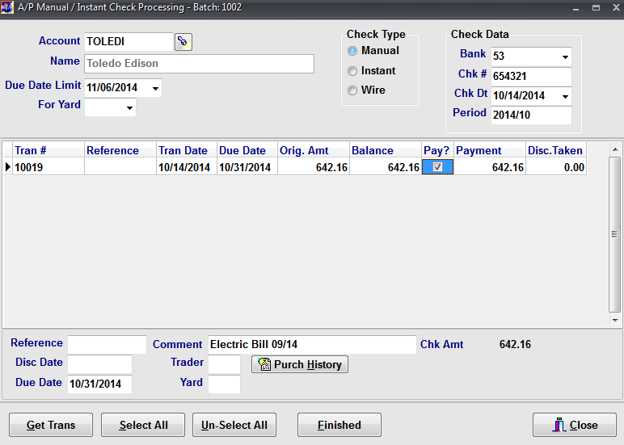The transactions will list below in the grid and click the check box in the ‘Pay?’ column for the items to be paid.
  5. Select the appropriate Bank.
  6. Enter the check number.
  7. The check date will default to today’s date but can be changed.
  8. Ensure the Period is correct.
  9. Click the ‘Finished’ button at the bottom to complete this step.

Once the check has been recorded in the Manual Check program, it will need to be posted as we did in previous sections. To verify what is to be paid, run the Check Register for the Batch. The report for the batch will show the details of the payment. If everything is correct, run the Update Checks / ACH program for the appropriate batch. Run the Aging for the Account and you will notice that the amount is no longer showing.